

OOP Lab-12 Task

Name: Syed Muhammad Raza Ali

Enrolment: 02-134231-028

Course: OOP Lab

Faculty: Miss Hafsa Munawar

|  |
| --- |
| **Lab12: Database Connectivity** |

Designing and implementing Java programs that deal with:

|  |
| --- |
| **JDBC <-> ODBC** |

|  |
| --- |
| **Exercise:** |

Exercise

Create an application for the student enrollment system where student is enrolled in the university. Create proper dataset to store information for a student an apply CRUD operations over the students enrollment application. Also have the appropriate designing and login system for admin.

Code:

Entering data in Dbms on Submit button

private void jButton1ActionPerformed(java.awt.event.ActionEvent evt) {

try {

int id, salary;

String name;

database = new Db();

name = txtEname.getText();

id = Integer.parseInt(txtEmpid.getText());

salary = Integer.parseInt(txtSal.getText());

String query = "Insert into emp(empno, ename, sal) values (" + id + ",'" + name + "'," + salary + ")";

} catch (SQLException ex) {

Logger.getLogger(EmpForm.class.getName()).log(Level.SEVERE, null, ex);

}

}

Fetching data from Dbms on Display Button:

private void jButton2ActionPerformed(java.awt.event.ActionEvent evt) {

try {

String name, id, salary;

database = new Db();

String query = "select * from emp";

ResultSet reSet = database.runSelect(query);

DefaultTableModel model = (DefaultTableModel) tableEmp.getModel();

while (reSet.next()) {

id = reSet.getString("empno");

salary = reSet.getString("sal");

name = reSet.getString("ename");

String[] obj = {id, name, salary};

model.addRow(obj);

}

} catch (SQLException ex) {

Logger.getLogger(EmpForm.class.getName()).log(Level.SEVERE, null, ex);

}

}

Application Class:

package Demodb;

import java.sql.Connection;

import java.sql.DriverManager;

import java.sql.ResultSet;

import java.sql.PreparedStatement;

import java.sql.SQLException;

public class Db {

private static final String dLoc = "jdbc:ucanaccess://Demodb.accdb";

private Connection con;

private PreparedStatement pState;

private ResultSet resSet;

public Db() throws SQLException {

try {

con = DriverManager.getConnection(dLoc);

System.out.println("Connected!");

} catch (SQLException e) {

System.out.println(e.getMessage());

}

}

public void dmlOperation(String sqlQuery) {

try {

pState = con.prepareStatement(sqlQuery);

pState.executeUpdate();

System.out.println("Update sucessfull");

} catch (SQLException e) {

System.out.println(e.getMessage());

}

}

public ResultSet runSelect(String sqlQuery) {

try {

pState = con.prepareStatement(sqlQuery);

resSet = pState.executeQuery();

} catch (SQLException e) {

System.out.println(e.getMessage());

return null;

}

return resSet;

}

}

Output:

Entering Data Using form:

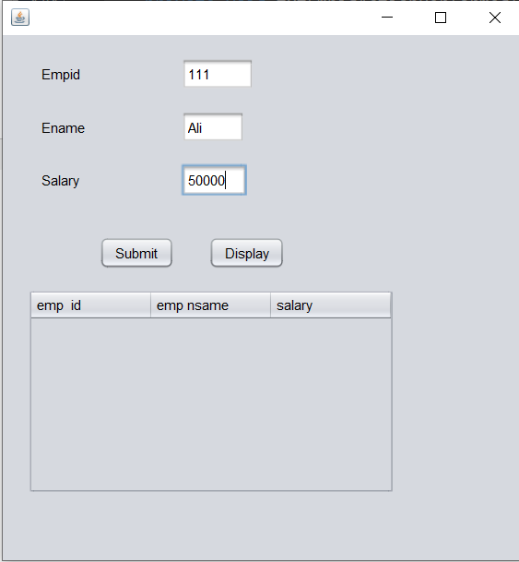

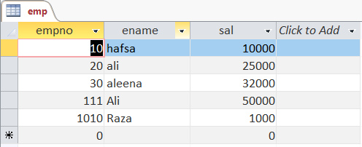

Fetching Data:

